Fs=270K,Fc=280K, Amp: 60mV/2, (0dB RF Gain, 16dB IF Gain)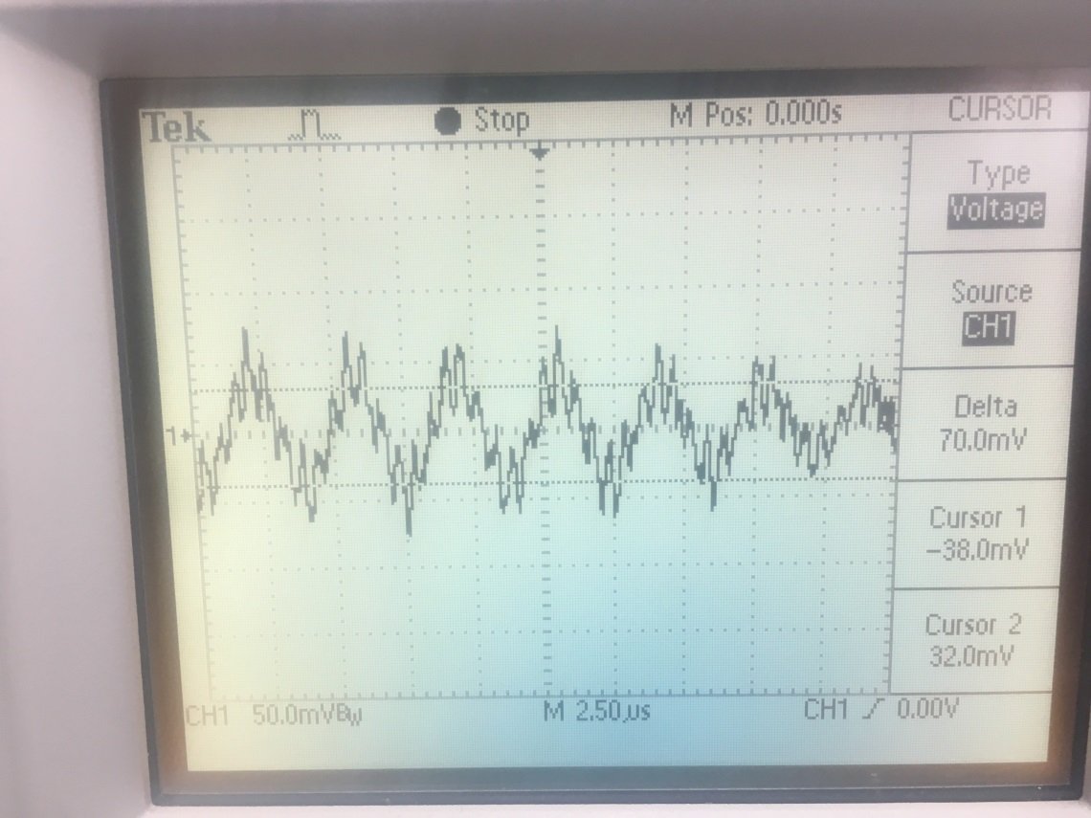

Fs=2M,Fc=2.01M,Amp: 252mV-632mV/2, , (0dB RF Gain, 16dB IF Gain)

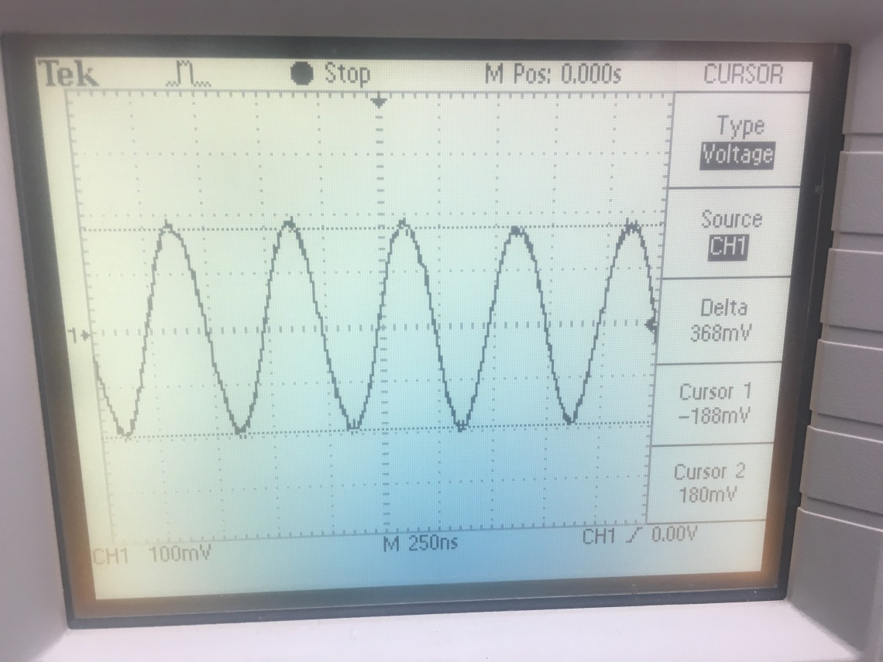

About 17dB Attenuation, external amplifier?

Fs=280K,Fc=10K,1A , (0dB RF Gain, 1dB IF Gain)

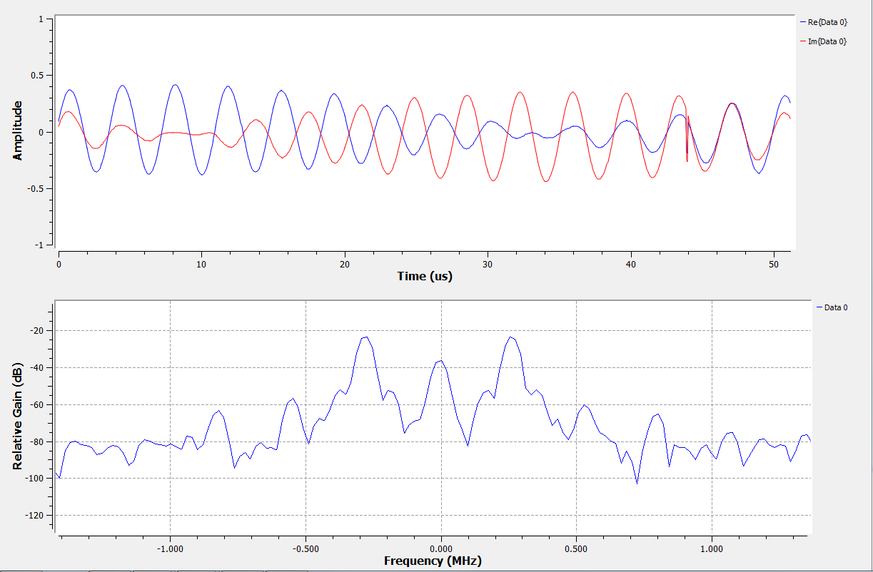

Fs=280K,Fc=10K,1mA , (0dB RF Gain, 1dB IF Gain)

